Object Specification - interfaces

Functional Specification – Technical Specification – Release Notes

|  |  |
| --- | --- |
| Document Name: | ACU-EXCELERATE-RTR-I-328 Inbound Credit rating interface with Experian |
| Document Version: | 1.02 |
| Document Status: | Completed |
| Document Update Date: | 10/04/2024 |





**Program *EXCEL*erate**

***Transform today, Excel tomorrow***

# Document Information

|  |  |
| --- | --- |
| Item | Description |
| Initial Author | Piyumi Weeraman |
| Object Specification Name | ACU-EXCELERATE-FS-RTR-I-328- Inbound Credit rating interface with Experian |
| Blueprint Specification Reference | RTR02-Accounts Receivables |
| Document Version | 1.02 |

*(Please add or remove responsible parties to the below table according to the approval process in project )*

|  |  |
| --- | --- |
| Client Source |  |
| Priority | High - Mandatory |
| Core Team Owner: | Piyumi Weeraman |
| Contact Number: |  |
| Email: | Piyumi.weeraman@rizing.com |
| Completed On: | Friday, October 04, 2024 |
| Functional Spec Completed By: | Piyumi Weeraman |
| Contact Number: |  |
| Email: | Piyumi.weeraman@rizing.com |
| Completed On: | Friday, October 04, 2024 |
| Functional Spec Approved By: |  |
| Contact Number: |  |
| Email: |  |
| Approved On: | Click here to enter a date. |
| Technical Spec Completed By: | Chuak Fen Soo |
| Contact Number: |  |
| Email: | [Chuakfen.soo@rizing.com](mailto:Chuakfen.soo@rizing.com) |
| Completed On: | Wednesday, November 27, 2024 |
| Technical Spec Approved By: | Prakash Sivakumar |
| Contact Number: |  |
| Email: | Prakash.Sivakumar@rizing.com |
| Approved On: | Click here to enter a date. |
| Development Assigned To: | Chuak Fen Soo |
| Contact Number: |  |
| Email: | [Chuakfen.soo@rizing.com](mailto:Chuakfen.soo@rizing.com) |
| Completed On: | Wednesday, November 27, 2024 |
| Development Approved By: | Prakash Sivakumar |
| Contact Number: |  |
| Email: | Prakash.Sivakumar@rizing.com |
| Approved On: | Click here to enter a date. |
| Middleware Config Assigned To :  Contact Number :  Email :  Completed On : | Click here to enter a date. |
| Off-Shore QA Approved By: |  |
| Contact Number: |  |
| Email: |  |
| Approved On: | Click here to enter a date. |
| On-Site QA Approved By: |  |
| Contact Number: |  |
| Email: |  |
| Approved On: | Click here to enter a date. |

**Document History**

|  |  |  |  |  |  |
| --- | --- | --- | --- | --- | --- |
| Version | Description | Author | Prepared/ Modified Date | Reviewed / Approved By | **Approved / Reviewed Date** |
| 1.01 | Initial Version | Piyumi Weeraman | 01/10/2024 |  |  |
| 1.02 | Changes in the technical approach | Piyumi Weeraman | 09/10/2024 |  |  |
| 1.03 | Update Technical Specification | Chuak Fen Soo | 26/11/2024 | Prakash Sivakumar | 02/12/2024 |

# Documentation Roles

This describes who or what function is responsible for completing the various sections in this document.

**Business Requirements** – this section to be completed by the Business with the support of the Functional Consultant

**Functional Specification** – this section to be completed by the Functional Consultant with the support of the Business

**Technical Specification** – this section to be completed by the Technical Consultant with the support of the Functional Consultant

**Middleware Specification –** this section to be completed by the Middleware Consultant with the support of Functional / Technical Consultant

**Security** – this section to be completed by the Functional Consultant and the Technical Consultant

**Quality Assurance** – this section to be completed by the QA Team

**Release Notes –** this section can be completed by any team. They can add any notes relevant to the different release.

**Appendix** – this section to be updated, as needed, by any involved parties

# Table of Contents

**1 Business Requirements** 7

1.1 Business drivers and justification 7

1.2 General Requirements 7

1.3 Data Flow diagram 8

1.4 Sender System 8

1.4.1 Description of the sender system and its functionality 8

1.4.2 Process flow overview 8

1.5 Receiver System 8

1.5.1 Description of the Receiver System 8

1.5.2 Process flow overview 8

**2 Functional Specification 9**

2.1 Sender system 9

2.1.1 Process Flow Overview 9

2.1.2 Sender Message Content / Sample Message 9

2.1.3 Triggering Method 9

2.1.4 Special processing Notes 9

2.1.5 Status Updates / Message acknowledgements 9

2.1.6 Configuration Requirements 9

2.2 Receiver System 10

2.2.1 Process flow overview 10

2.2.2 Receiving system data format 10

2.2.3 Special processing notes 10

2.2.4 Configuration requirements 10

2.3 Data mappings 10

2.4 Message monitoring and re-processing 10

2.5 Role of middleware tool 10

**3 Technical Specification 11**

3.1 Assumptions 11

3.2 Sender system 11

3.2.1 Technical developments or configurable components on sender system 11

3.2.2 Communication method 11

3.2.3 Sender message structure in detail 11

3.2.4 Detailed Design 11

3.2.5 Security & Authorization Objects 12

3.3 Receiver system 12

3.3.1 Technical developments or configurable components in receiver system 12

3.3.2 Communication method 12

3.3.3 Receiver message structure in detail 12

3.3.4 Detailed design 12

3.3.5 Message monitoring and re-processing 13

3.3.6 Security & Authorization Objects 13

**4 Middleware Specification 1**3

4.1 SLD Configurations 13

4.2 Integration Directory 13

4.2.1 Configuration Scenario 14

4.2.2 Sender Communication Channel 14

4.2.3 Receiver Communication Channel 14

4.3 Integration Repository 14

4.3.1 Data Types 14

4.3.2 Message Types 14

4.3.3 External Definitions 14

4.3.4 Mapping Objects 14

4.3.5 UDF Details 14

4.3.6 Operational Mapping 14

4.4 Alerts 15

4.5 Additional configurations required on sender , receiver and middleware systems 15

**5 Quality Assurance Requirements 1**5

5.2 Test scenarios & data 15

**6 Release Notes 1****5**

**7 Appendix 1**5

1. Business Requirements
   1. Business drivers and justification

*Acushnet Finance receives credit ratings for its customers from an external credit rating agency; Experian. As a prerequisite to this step, all the payment details of the customers are shared with Experian beforehand and Experian re-calculates the revised credit ratings.*

*Once the revised ratings are available from Experian, web methods accesses this data directly through a sequel, then web methods converts the Experian rating to a rating (numeric) which the ERP system can understand. Then the ERP system extracts this information and update the system accordingly.*

* 1. General Requirements

*(Describe the general requirements.)*

|  |  |
| --- | --- |
| What is the processing frequency for this Interface? | Twice a year |
| What is the expected volume of messages processed via this interface? | 5000 to 6000 records |
| What type(s) of business data will be contained in the message?  (Order data, invoice data, inventory data, shipping papers, quality data, etc.) | BP / Customer number and Credit Score |
| Sender System Name | Experian system |
| Receive System Name | SAP S4 HANA |
| Middleware Name | Web methods |

* 1. Data Flow Diagram

Ex :

Web Methods

BAPI / API

Direct Sequel from Web methods

Experian

Receiver

* 1. Sender System
     + 1. Description of the sender system and its functionality

*Experian would be the sender system which calculates the credit ratings of Acushnet customers and it will send the calculated ratings to web methods middle ware.*

* + - 1. Process flow overview

*~~A direct sequel from web methods will extract the data from the sender system.~~*

*A file will be extracted from Experian SFTP site which will be used to update the rates in SAP.*

* 1. Receiver System
     + 1. Description of the Receiver System

*The receiver system would be SAP S4 HANA*

* + - 1. Process flow overview

Web methods would convert the ratings calculated by Experian to ratings which SAP can understand which will be received by SAP system to update the BP master external credit rating information.

1. Functional Specification
   1. Sender system
      * 1. Process Flow Overview

*Acushnet is using Experian as the external credit rating agency which would calculate the credit rating of all its customers. Web methods will pull the re-calculated new ratings from Acushnet and will convert them to rates that SAP has.*

* + - 1. Sender Message Content / Sample Message

*Attached below is the CSV file currently generated by web methods which is sent to legacy ERP*

**

* + - 1. Triggering Method

*Once Experian calculates revised rates based on the latest data of the Acushnet customers the data will be sent to middle-ware.*

* + - 1. Special Processing Notes

*(Explain any special business logics needs to implement in sender system to filter or convert data)*

* + - 1. Status Updates / Message acknowledgements

*(Explain any status updates or message acknowledgements required by sender system to complete the outbound message process)*

* + - 1. Configuration Requirements

*(Explain any configuration requirements on sender system Ex: Scheduling / Enabling functions)*

* 1. Receiver System
     + 1. Process flow overview

*SAP would receive the converted data from web methods. SAP would require below data elements in the incoming message from web methods in order to update the credit rating SAP.*

* *SAP customer number*
* *Rating procedure - (this can be set to EXPERIAN as a constant / or can be received as part of middleware message.*
* *Rating - (Number ranging from 0 to 5)*
* *Valid from date – (the date the interface runs)*
* *Valid to date - (can be part of the message received from middle ware)*
* *Rated When date - (the date that the interface runs)* 
  + - 1. Receiving system data format

*This will be used to update BP master- credit management related data in SAP. Data received via this interface will update the below fields in the BP master.*

* + - 1. Special processing notes

*(Explain any special program logics needs to implement in receiver system to filter or convert data)*

* + - 1. Configuration requirements

Set up rating procedure

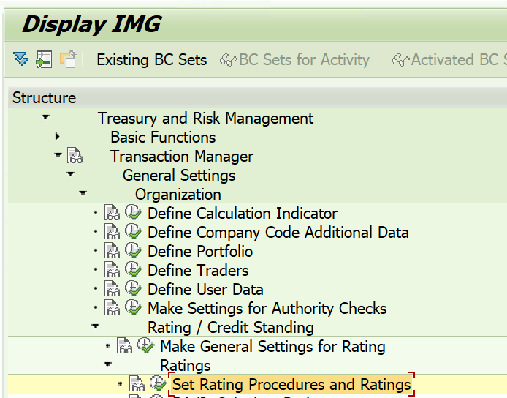

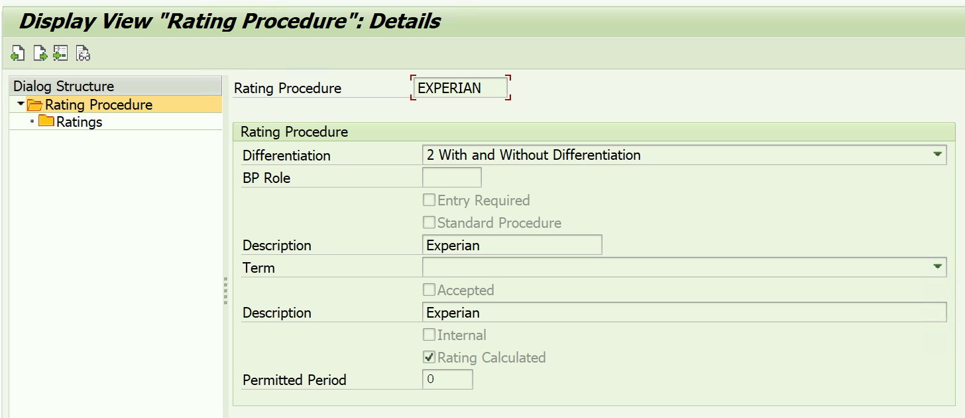

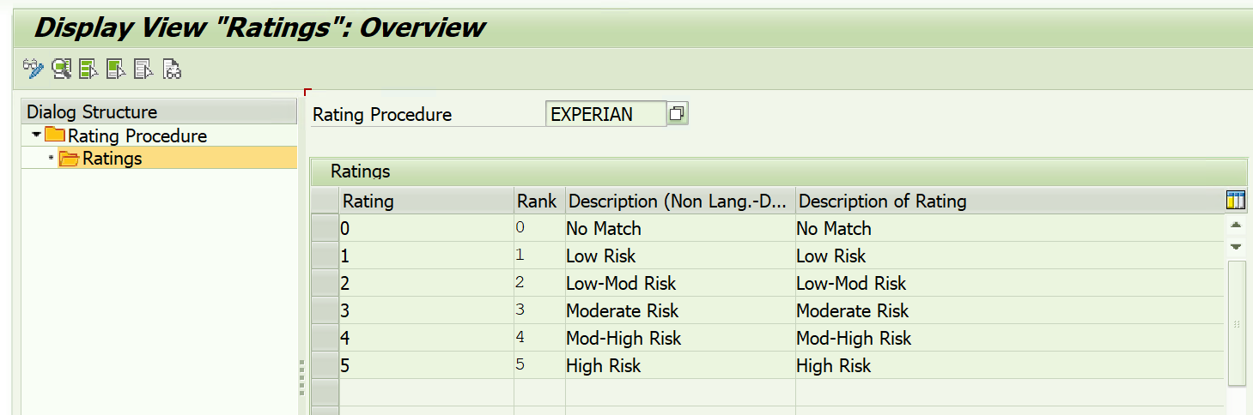

Below BAPIs can be used to add a new rating and to change an existing rating. BAPIs can be converted to a direct API call from the middleware which would update the date in SAP BP master. Currently, Acushnet is not Changing the existing ratings within the validity period. A new rating is updated every six months.

BAPI_BUPA_FS_RATING_ADD

This is used to add a new line to the external credit information table in the BP master. The prerequisite is that the validity period of the new rating should not overlap with the already existing validity period.

BAPI_BUPA_FS_RATING_CHANGE

If the business wants to change the rating within the same validity period this BAPI can be used. The pre-requisite is that the “Valid to” date in the incoming message should be exactly the same as the already existing valid to date.

* 1. Data mappings



* 1. Message monitoring and re-processing

*(Explain message monitoring/reprocessing facilities required on the receiving system ex: EDI Cockpit)*

* 1. Role of middleware tool

*WebMethods would be the middleware which is used in this interface.*

***NOTE:***

SAP’s recommendation is to utilize “SAP S/⁠4HANA Cloud for credit integration” solution for this purpose. It allows credit controllers to quickly access and request the newest credit information provided by external credit agencies. This credit integration solution acts as the hub located between SAP Credit Management system and the credit agencies. The external credit agencies are integrated using credit integration solution on the SAP BTP, Cloud Foundry environment.

However, **Experian** is not listed as a credit agency that is currently available under this solution. Additionally, even though SAP S/⁠4HANA Cloud for credit integration connects businesses to the services provided by credit agencies it does NOT include the licenses at the credit agencies. This means that businesses need to obtain the necessary licenses at credit agencies. You also need the user account data of the credit agencies to connect SAP credit integration solution to their services.

Due to limitations outlined above ‘SAP Cloud for Credit Integration’ solution will not be used for the purpose of this interface at Acushnet.

Additionally, the possibility of using the below API was explored. However, while testing the APIs it was identified that the target fields in SAP are not populated in this API provided by SAP for credit management BP master create/ change option.

* **API_CRDTMBUSINESSPARTNER_0001** (This service enables the maintenance of data related to SAP Credit Management for business partners)

1. Technical Specification
   1. Assumptions
      * + 1. API needs to be activated for SAP to receive credit rating from Experian and to be updated into the BP master external credit rating information.
   2. Sender system
      * 1. Technical developments or configurable components on sender system

N/A

* + - 1. Communication method

N/A

* + - 1. Sender message structure in detail

N/A

* + - 1. Detailed Design
         1. N/A

Object names

N/A

Tables Used

N/A

Data Selection

N/A

Program Interfaces

N/A

* + - 1. Security & Authorization Objects

N/A

* 1. Receiver system
     + 1. Technical developments or configurable components in receiver system
          1. This development involves creating a custom Web API that can implements custom logic to add/change EXPERIAN credit rating in Business Partner Credit Management from transaction code ‘BP’. The add and change credit rating functionalities would be done by executing the call to BAPI_BUPA_FS_RATING_ADD and BAPI_BUPA_FS_RATING_CHANGE respectively.
       2. Communication method

API - ODATA

* + - 1. Receiver message structure in detail

|  |  |  |  |
| --- | --- | --- | --- |
| *(*Object Type | Name | Data types | Data Length |
| CustomerNumber | Business Partner | c | 10 |
| Rating | Credit Rating Value | c | 10 |
| ValidToDate | Valid To Date | c | 8 |

* + - 1. Detailed design
         1. Build a RAP model referencing to BP1012 table:
         2. Create Root CDS Entity, Consumption View, and Abstract View.
         3. Create a Behavior Definition.
         4. Create a Service Definition.
         5. Create Service Binding.
         6. Add custom logic with BAPI_BUPA_FS_RATING_ADD and BAPI_BUPA_FS_RATING_CHANGE through the implementations of Interface Class, Factory Class and BAPI wrapper class.
         7. Publish the OData V4 Web API service.

Object names

Provide the following information:

|  |  |
| --- | --- |
| Object Type | Name |
| Package | ZRTR_I_328_T2 |
| Data Definition Language Source | ZRTR_R_RATING |
| Package | ZRTR_I_328_T1 |
| Data Definition Language Source | ZRTR_R_BPCREDIT_RATING |
| Class (ABAP Objects) | ZCL_RTR_BP_CREDITRTG_UPD |
| Data Definition Language Source | ZRTR_ABSTRACT_BP_CREDITRTG |
| Data Definition Language Source | ZRTR_C_BPCREDIT_RATING |
| Behavior Definition | ZRTR_R_BPCREDIT_RATING |
| Behavior Definition | ZRTR_C_BPCREDIT_RATING |
| Class (ABAP Objects) | ZBP_RTR_R_BPCREDIT_RATING |
| Service Definition | ZRTR_API_BP_CREDIT_RTG_O4 |
| Service Binding | ZRTR_API_BP_CREDIT_RTG_O4 |
| SAP Gateway OData V4 Backend Service Group & Assignments | ZRTR_API_BP_CREDIT_RTG_O4 |
| Data Element | ZDE_TIMESTAMP |
| Data Element | ZDE_DFTVAL |
| Data Element | ZDE_DATE_TO |
| Data Element | ZDE_GRADE_METHOD |
| Data Element | ZDE_DATE_FROM |
| Data Element | ZDE_FLG_PERMIT |
| Data Element | ZDE_GRADE |
| Data Element | ZDE_DATE_WHEN |
| Data Element | ZDE_TENDENCY |
| Data Element | ZDE_FLG_DEFAULT |
| Data Element | ZDE_TEXT |
| Class (ABAP Objects) | ZCL_RTR_BP_CREDITRTG_UPD |
| Behavior Definition | ZRTR_R_BPCREDIT_RATING |
| Class (ABAP Objects) | ZBP_RTR_R_BPCREDIT_RATING |
| Interface (ABAP Objects) | ZIF_RTR_MODIFY_BP_CREDITRATING |
| Class (ABAP Objects) | ZCL_RTR_MODIFY_BP_CREDITRATING |
| Structure | ZRTR_CREDITRATINGX_S |
| Structure | ZRTR_CREDITRATING_S |

Tables Used

N/A

Program Interfaces

|  |  |  |
| --- | --- | --- |
| Object Type | Name | Description |
| BAPI | BAPI_BUPA_FS_RATING_ADD | Create Ratings |
| BAPI | BAPI_BUPA_FS_RATING_CHANGE | Change Ratings |
| Function Module | RP_CALC_DATE_IN_INTERVAL | Date +/- year/month/day (into the future/past) |

* + - 1. Message monitoring and re-processing

N/A

* + - 1. Security & Authorization Objects

N/A

1. Middleware Specification

(Below section is specifically for SAP PI/PO middleware tool. If you are using a different tool please change below section accordingly and use. If the middleware object handled by a third-party they should maintain their own specifications)

* 1. SLD Configurations

|  |  |  |  |  |
| --- | --- | --- | --- | --- |
| Product | Software component | Software version: | Technical system | Business system |
|  |  |  |  |  |
| . |  |  |  |  |

* 1. Integration Directory
* (Include screenshots of middleware configurations )
  + - 1. Configuration Scenario
      2. Sender Communication Channel
      3. Receiver Communication Channel
  1. Integration Repository
     + 1. Data Types
       2. Message Types
       3. External Definitions
       4. Mapping Objects
       5. UDF Details
       6. Operational Mapping
  2. Alerts

*(Provide any alerts configured in middleware system)*

* 1. Additional configurations required on sender , receiver and middleware systems

*(Explain any configurations required on each system for the integration to work)*

*Eg: RFC Destinations*

1. Quality Assurance Requirements
   * + - 1. Describe the (Quality Assurance scope, such as levels of unit and integration testing, automated testing tools, sign-off procedures, etc.)
   1. Test scenarios & data

*(Provide test scenarios and test data in the above excel sheet)*

1. Release Notes
   * 1. Developers / QA team / Consultant Notes
     2. Document any and all test cases and integration testing scenarios or scripts.
2. Appendix
   * 1. Please note any links to external documents, such as Blueprints or other requirement documents, which may be useful and relevant to this document.

|  |  |
| --- | --- |
| Document Name | Document Path or Link |
|  |  |



Providing best-in-class solutions to meet the global demand for SAP consulting, products and implementation services.

Rizing, a wipro company enables every business that uses SAP solutions to achieve a truly intelligent enterprise. We do this for Human Capital Management, Enterprise Asset Management, Consumer Industries and Geospatial Solutions with leading SAP technologies and our own deep industry experience. Rizing provides services and our proprietary apps leveraging the SAP Cloud Platform to Fortune 500 and small/medium enterprises. Our mission is always to propel your organisation along the transformation journey.

rizing.com